**County of Mono**

**Department of Animal Services**

Annex III

199 Twin Lakes Road * P.O. Box 263

Bridgeport, CA 93517

(760) 932-5630 * Fax (760) 932-2626

animal@mono.ca.gov

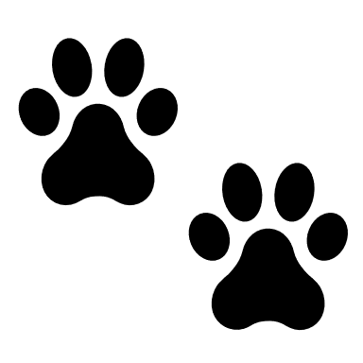===================================================================================================================

**Low Cost Spay/Neuter Voucher Application**

Thank you for your interest in spaying or neutering your pet! This program is available to qualifying applicants to provide a discount for your pet’s spay/neuter surgery. Please fill this application out and send it to the office via mail, email, or you may drop it off at any of our shelters. A voucher will be issued to qualifying applicants and sent via email. It will be the pet owner’s responsibility to make an appointment with the participating vet prior to the voucher expiration date.

**What are the requirements for being eligible?**

1. Be a permanent resident of Mono County including Mammoth Lakes, or a military family based in Mono County.

1. If this voucher is for your dog, you must have a current dog license either with Mono County Animal Services or with the Mammoth Lakes Police Department.

Please complete the following to the best of your knowledge. A voucher will be emailed to the email address provided in this application, upon review.

============================================================================

**Owner information**

First and Last name: ________________________________________________________

Physical Address: __________________________________________________________

Mailing Address: _______________________________City: ________________________ Zip _____________________ Phone Number(s):__________________________________

Email: ________________________________________________________

____ I am at least 18 years of age and the legal owner of this animal

**Pet Information**

Circle one: [Dog] [Cat]

Dog License # __________________

Name____________________ Breed _________________ Gender: _________ Age ______

Color _____________________________________________________________________

**==========================================================================**

**Pet Information**

Circle one: [Dog] [Cat]

Dog License # __________________

Name____________________ Breed _________________ Gender: _________ Age ______

Color _____________________________________________________________________

**==========================================================================**

**Pet Information**

Circle one: [Dog] [Cat]

Dog License # __________________

Name____________________ Breed _________________ Gender: _________ Age ______

Color _____________________________________________________________________

**==========================================================================**

**Pet Information**

Circle one: [Dog] [Cat]

Dog License # __________________

Name____________________ Breed _________________ Gender: _________ Age ______

Color _____________________________________________________________________

**Please initial the option that applies**

**______ I can transport my pet**

Upon receiving your pet’s voucher, it is your responsibility to make an appointment with the vet before the voucher expires.

This is a shared cost program. Complications may arise causing the bill to alter. It is your responsibility to cover any extra costs.

You must fast your pet prior to surgery. Please ask the vet if you have any questions.

**_____ I would like to request pet transportation**

A Mono County Animal Services Officer can pick up your pet. They will spend the night at the shelter prior to the day of surgery.

Upon receiving your voucher, you will need to call the vet to “pre-register” your pet and provide them your credit card information for billing. Once you have done that, the vet will notify Animal Services that your pet is ready to be transported. You are not making an appointment. You are providing information ahead of time. An Officer will then contact you to arrange a pickup date. When the surgery is over, the Officer will bring your pet back to you.

By choosing this option you understand that transporting and sheltering can be risky. Your animal may sustain injuries in transport or illness in the shelter. By choosing this option, you are agreeing to not hold Mono County Animal Services liable for any damages to your pet while your pet is in their care and custody.

**Costs**

This program is a shared cost program, Mono County pays a portion of the surgery to lower the cost for the owner. Remember that complications from pregnancy and cryptorchidism may apply, causing the cost for the owner to alter. Mono County’s contribution is fixed. Any alterations in the cost are the owner’s responsibility.

The following table shows prices for each surgery at the Bishop Veterinary Hospital – Mammoth and Bishop locations.

Sharing the costs

When an animal is spayed or neutered using the County issued voucher, Bishop Vet will split the bill between the owner and the county. Review the chart below to see what you, as the owner, can expect to pay and what part of the bill the county will cover. **Surgeries that require more anesthesia and time will cost more.**

Dog

|  |  |  |  |
| --- | --- | --- | --- |
| Neuter | | Spay | |
| County Pays | Owner Pays | County Pays | Owner Pays |
| $123 | $124 | $137 | $138 |

Cat

|  |  |  |  |
| --- | --- | --- | --- |
| Neuter | | Spay | |
| County Pays | Owner Pays | County Pays | Owner Pays |
| $57 | $58 | $121 | $122 |

|  |
| --- |
| **Participating Vet** |
| Bishop Veterinarian Hospital |
| Both Mammoth and Bishop Locations |