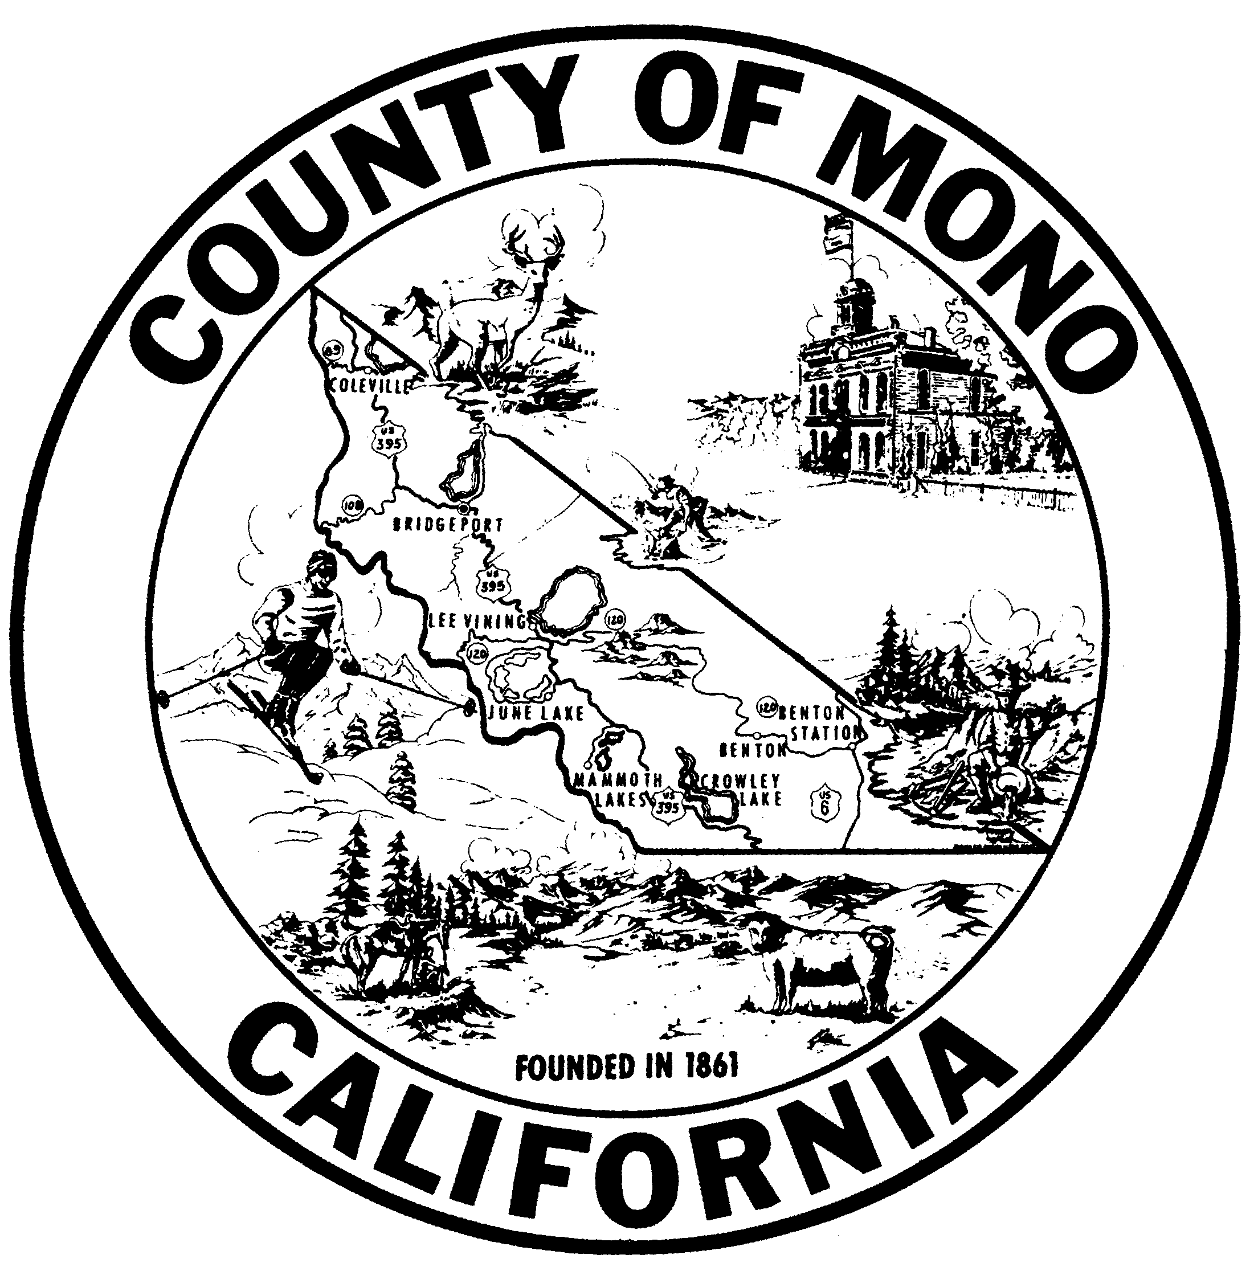 | C L E R K – R E CO R D E R – R E G I S T R A R  COUNTY OF MONO  P.O. BOX 237, BRIDGEPORT, CALIFORNIA 93517  (760) 932-5538 • FAX (760) 932-5531
Lynda Roberts  Clerk-Recorder  lroberts@mono.ca.gov |  |  | Linda Romero  Assistant Clerk-Recorder  lromero@mono.ca.gov

NOTICE OF MANDATORY FEE INCREASE EFFECTIVE JANUARY 1, 2014
Pursuant to Assembly Bill (AB) 1053 (Gordon, Chapter 402, Statutes of 2011) and AB 110 (Blumenfield, Chapter 20, Statutes of 2013), the following fees listed in the table below will be increased effective January 1, 2014.

Name of Fee | Current Fee | January 1, 2014
Birth—General Public | $20.00 | $25.00
Birth—Gov’t Agency | $14.00 | $19.00
Death—Gov’t Agency/Gen Public | $16.00 | $21.00
Fetal Death—Gov’t Agency/Gen Public | $13.00 | $18.00
Marriage—Certified Copy Gen Public | $14.00 | $15.00
Marriage—Certified Copy Gov’t Agency | $10.00 | $11.00
Permit: Disposition of Human Remains | $11.00 | $12.00

Lynda Roberts, Mono County Clerk-Recorder

