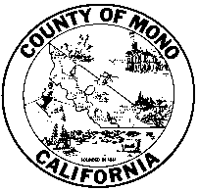 | C L E R K – R E C O R D E R – R E G I S T R A R  COUNTY OF MONO
Notary Consumer Disclosure Requirement (SB 1050)

Effective January 1, 2015, pursuant to Senate Bill 1050, the Mono County
Clerk’s Office will require the Notary Consumer Disclosure. This bill requires a legible notice at the top of the certificate of acknowledgment in
an enclosed box, stating that the acknowledgment, proof of execution, or jurat verifies only the identity of the individual who signed the document to which the acknowledgment, proof of execution, or jurat is attached, and not the truthfulness, accuracy, or validity of the document.

Documents where the person appeared before a notary or other officer on or after January 1, 2015 must have this disclosure or will be rejected. Documents acknowledged before January 1, 2015 will be accepted for recording and must meet current applicable statue.

A notary public or other officer completing this certificate verifies only the identity of the individual who signed the document, to which this certificate is attached, and not the truthfulness, accuracy, or validity of that document.

This requirement has been made in accordance with the legislative amendment to Sections 1189 and 1195 and Government Code Section 8202, relating to notaries public.

