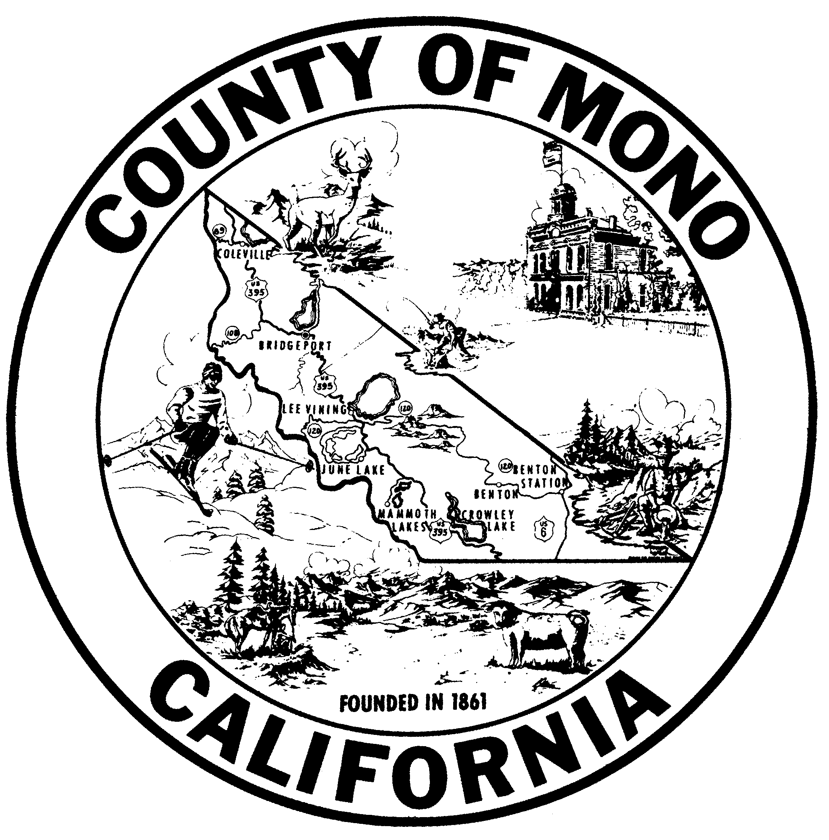 | MONO COUNTY HEALTH DEPARTMENT  P.O. Box 476, Bridgeport, California 93517 (760) 932-5580 • Fax (760) 932-5284  P.O. Box 3329, mammoth lakes, California 93546 (760) 924-1800 • Fax (760) 924-1801

MASTER FILE RECORD INFORMATION

FACILITY INFORMATION
Facility ID__________________ Facility type __________________ APN ______________
New facility Update for existing facility Change of ownership-Date effective:_______

Facility name _________________________________________________________________
Physical site address ___________________________________________________________
City __________________________________ State ______________ Zip _______________
Cross street___________________________________________________________________

Facility mailing address _________________________________________________________
City __________________________________ State ______________ Zip _______________

Phone ___________________ Ext. _____ Alternate phone ___________________ Ext. _____
Fax _______________________________ E-mail ___________________________________
Manager name ________________________________ Phone __________________________

EMERGENCY NOTIFICATION
Facility emergency coordinator ___________________________________________________
Contact #1:____________________ Day phone _____________ Night phone ______________
Contact #2:____________________ Day phone _____________ Night phone ______________

OWNER INFORMATION
Sole proprietor Partnership Corporation
Owner name __________________________________________________________________
Physical address _______________________________________________________________
City _____________________________ State ______________________ Zip _____________
Home phone ______________________ Work phone _________________________________
Mailing address _______________________________________________________________
City _____________________________ State ______________________ Zip _____________
Contact name(s), if a corporation _________________________________________________

Co-owner name(s), if a partnership ________________________________________________
Address ______________________________________________________________________
City _____________________________ State ______________________ Zip _____________

Mail invoices to: Owner Facility
Mail permits to: Owner Facility

